Demographic Sentencing Disparities Baseline Switch
December 22, 2022
Final Fall 2022 Version
This document attempts to replicate the Commission’s “refined model” for estimating demographic disparities in sentencing. For more information about the model and for the reference regressions, see “Demographic Disparities Baseline Switch Reference Docs.” For a write-up of findings, see the latest version of the Data Learnings Memo.

White Male Baseline Regressions

Post-Protect
 | Estimate | Standard Error | t value | Pr(>|t|)
(Intercept) | 0.561 | 0.027 | 20.667 | 0.0000 | ***
logmin | 0.690 | 0.002 | 281.184 | 0.0000 | ***
drugtraffTRUE | 0.215 | 0.016 | 13.124 | 0.0000 | ***
sexual2TRUE | 0.203 | 0.063 | 3.229 | 0.0012 | **
pornTRUE | 0.221 | 0.050 | 4.431 | 0.0000 | ***
immigrationTRUE | 0.168 | 0.021 | 7.924 | 0.0000 | ***
othtype2TRUE | -0.238 | 0.027 | -8.726 | 0.0000 | ***
whitecollTRUE | -0.343 | 0.019 | -17.670 | 0.0000 | ***
upwardTRUE | 1.083 | 0.055 | 19.798 | 0.0000 | ***
downdepTRUE | -0.897 | 0.016 | -55.852 | 0.0000 | ***
subasstTRUE | -1.178 | 0.015 | -76.716 | 0.0000 | ***
mandmin2TRUE | 0.104 | 0.017 | 5.941 | 0.0000 | ***
NEWCNVTN | 0.265 | 0.024 | 10.899 | 0.0000 | ***
custodyTRUE | 0.753 | 0.013 | 57.400 | 0.0000 | ***
relevel(factor(racesex), ref = 8)blackfemale | -0.418 | 0.028 | -15.083 | 0.0000 | ***
relevel(factor(racesex), ref = 8)blackmale | 0.098 | 0.015 | 6.473 | 0.0000 | ***
relevel(factor(racesex), ref = 8)hispfemale | -0.284 | 0.028 | -9.971 | 0.0000 | ***
relevel(factor(racesex), ref = 8)hispmale | -0.009 | 0.017 | -0.545 | 0.5858
relevel(factor(racesex), ref = 8)otherfemale | -0.566 | 0.056 | -10.076 | 0.0000 | ***
relevel(factor(racesex), ref = 8)othermale | -0.071 | 0.030 | -2.379 | 0.0174 | *
relevel(factor(racesex), ref = 8)whitefemale | -0.274 | 0.024 | -11.336 | 0.0000 | ***
agedummyTRUE | 0.035 | 0.012 | 2.829 | 0.0047 | **
educTRUE | -0.059 | 0.013 | -4.486 | 0.0000 | ***
citizenTRUE | -0.029 | 0.016 | -1.821 | 0.0685 | .
Signif. codes: 0 <= '***' < 0.001 < '**' < 0.01 < '*' < 0.05
Residual standard error: 1.326 on 70385 degrees of freedom
Multiple R-squared: 0.7127, Adjusted R-squared: 0.7127
F-statistic: 7593 on 70385 and 23 DF, p-value: 0.0000

Post-Booker
 | Estimate | Standard Error | t value | Pr(>|t|)
(Intercept) | 0.503 | 0.017 | 29.030 | 0.0000 | ***
logmin | 0.700 | 0.002 | 421.092 | 0.0000 | ***
drugtraffTRUE | 0.207 | 0.010 | 20.275 | 0.0000 | ***
sexual2TRUE | 0.134 | 0.038 | 3.545 | 0.0004 | ***
pornTRUE | 0.418 | 0.025 | 16.664 | 0.0000 | ***
immigrationTRUE | 0.149 | 0.013 | 11.546 | 0.0000 | ***
othtype2TRUE | -0.443 | 0.018 | -25.132 | 0.0000 | ***
whitecollTRUE | -0.335 | 0.012 | -27.253 | 0.0000 | ***
upwardTRUE | 0.982 | 0.025 | 39.962 | 0.0000 | ***
downdepTRUE | -0.916 | 0.008 | -116.794 | 0.0000 | ***
subasstTRUE | -1.083 | 0.010 | -107.939 | 0.0000 | ***
mandmin2TRUE | 0.195 | 0.010 | 18.923 | 0.0000 | ***
NEWCNVTN | 0.312 | 0.015 | 20.949 | 0.0000 | ***
custodyTRUE | 0.761 | 0.008 | 91.017 | 0.0000 | ***
relevel(factor(racesex), ref = 8)blackfemale | -0.293 | 0.018 | -16.055 | 0.0000 | ***
relevel(factor(racesex), ref = 8)blackmale | 0.156 | 0.010 | 16.392 | 0.0000 | ***
relevel(factor(racesex), ref = 8)hispfemale | -0.265 | 0.017 | -15.354 | 0.0000 | ***
relevel(factor(racesex), ref = 8)hispmale | -0.009 | 0.010 | -0.886 | 0.3756
relevel(factor(racesex), ref = 8)otherfemale | -0.251 | 0.034 | -7.372 | 0.0000 | ***
relevel(factor(racesex), ref = 8)othermale | 0.039 | 0.018 | 2.164 | 0.0305 | *
relevel(factor(racesex), ref = 8)whitefemale | -0.215 | 0.015 | -14.071 | 0.0000 | ***
agedummyTRUE | 0.042 | 0.008 | 5.401 | 0.0000 | ***
educTRUE | -0.060 | 0.008 | -7.299 | 0.0000 | ***
citizenTRUE | -0.071 | 0.010 | -7.213 | 0.0000 | ***
Signif. codes: 0 <= '***' < 0.001 < '**' < 0.01 < '*' < 0.05
Residual standard error: 1.347 on 190914 degrees of freedom
Multiple R-squared: 0.6755, Adjusted R-squared: 0.6755
F-statistic: 1.728e+04 on 190914 and 23 DF, p-value: 0.0000

Post-Gall
 | Estimate | Standard Error | t value | Pr(>|t|)
(Intercept) | 0.550 | 0.017 | 32.447 | 0.0000 | ***
logmin | 0.631 | 0.001 | 422.107 | 0.0000 | ***
drugtraffTRUE | 0.143 | 0.010 | 14.207 | 0.0000 | ***
sexual2TRUE | 0.168 | 0.037 | 4.590 | 0.0000 | ***
pornTRUE | 0.554 | 0.021 | 26.261 | 0.0000 | ***
immigrationTRUE | 0.102 | 0.012 | 8.251 | 0.0000 | ***
othtype2TRUE | -0.693 | 0.017 | -41.184 | 0.0000 | ***
whitecollTRUE | -0.368 | 0.012 | -30.477 | 0.0000 | ***
upwardTRUE | 0.880 | 0.021 | 41.568 | 0.0000 | ***
downdepTRUE | -0.969 | 0.007 | -139.554 | 0.0000 | ***
subasstTRUE | -1.021 | 0.010 | -101.740 | 0.0000 | ***
mandmin2TRUE | 0.412 | 0.010 | 42.067 | 0.0000 | ***
NEWCNVTN | 0.410 | 0.016 | 26.005 | 0.0000 | ***
custodyTRUE | 0.958 | 0.008 | 116.675 | 0.0000 | ***
relevel(factor(racesex), ref = 8)blackfemale | -0.415 | 0.019 | -22.351 | 0.0000 | ***
relevel(factor(racesex), ref = 8)blackmale | 0.174 | 0.009 | 18.458 | 0.0000 | ***
relevel(factor(racesex), ref = 8)hispfemale | -0.213 | 0.016 | -13.320 | 0.0000 | ***
relevel(factor(racesex), ref = 8)hispmale | 0.009 | 0.010 | 0.980 | 0.3270
relevel(factor(racesex), ref = 8)otherfemale | -0.432 | 0.034 | -12.515 | 0.0000 | ***
relevel(factor(racesex), ref = 8)othermale | 0.002 | 0.018 | 0.109 | 0.9132
relevel(factor(racesex), ref = 8)whitefemale | -0.384 | 0.015 | -26.319 | 0.0000 | ***
agedummyTRUE | 0.042 | 0.008 | 5.500 | 0.0000 | ***
educTRUE | -0.060 | 0.008 | -7.489 | 0.0000 | ***
citizenTRUE | -0.089 | 0.009 | -9.389 | 0.0000 | ***
Signif. codes: 0 <= '***' < 0.001 < '**' < 0.01 < '*' < 0.05
Residual standard error: 1.497 on 270474 degrees of freedom
Multiple R-squared: 0.6019, Adjusted R-squared: 0.6019
F-statistic: 1.778e+04 on 270474 and 23 DF, p-value: 0.0000

Post-Report
 | Estimate | Standard Error | t value | Pr(>|t|)
(Intercept) | 0.243 | 0.017 | 13.917 | 0.0000 | ***
logmin | 0.617 | 0.001 | 415.914 | 0.0000 | ***
drugtraffTRUE | 0.159 | 0.010 | 16.240 | 0.0000 | ***
sexual2TRUE | 0.220 | 0.030 | 7.290 | 0.0000 | ***
pornTRUE | 0.597 | 0.019 | 30.660 | 0.0000 | ***
immigrationTRUE | -0.062 | 0.012 | -5.018 | 0.0000 | ***
othtype2TRUE | -0.612 | 0.016 | -38.608 | 0.0000 | ***
whitecollTRUE | -0.223 | 0.012 | -19.022 | 0.0000 | ***
upwardTRUE | 0.675 | 0.020 | 34.259 | 0.0000 | ***
downdepTRUE | -1.033 | 0.007 | -154.793 | 0.0000 | ***
subasstTRUE | -1.095 | 0.010 | -109.557 | 0.0000 | ***
mandmin2TRUE | 0.477 | 0.010 | 49.090 | 0.0000 | ***
NEWCNVTN | 0.506 | 0.016 | 30.930 | 0.0000 | ***
custodyTRUE | 1.349 | 0.008 | 164.483 | 0.0000 | ***
relevel(factor(racesex), ref = 8)blackfemale | -0.354 | 0.018 | -19.675 | 0.0000 | ***
relevel(factor(racesex), ref = 8)blackmale | 0.167 | 0.010 | 17.444 | 0.0000 | ***
relevel(factor(racesex), ref = 8)hispfemale | -0.192 | 0.015 | -12.912 | 0.0000 | ***
relevel(factor(racesex), ref = 8)hispmale | 0.044 | 0.010 | 4.529 | 0.0000 | ***
relevel(factor(racesex), ref = 8)otherfemale | -0.443 | 0.032 | -13.972 | 0.0000 | ***
relevel(factor(racesex), ref = 8)othermale | -0.047 | 0.017 | -2.712 | 0.0067 | **
relevel(factor(racesex), ref = 8)whitefemale | -0.356 | 0.014 | -24.607 | 0.0000 | ***
agedummyTRUE | 0.035 | 0.008 | 4.494 | 0.0000 | ***
educTRUE | -0.003 | 0.008 | -0.391 | 0.6956
citizenTRUE | -0.040 | 0.009 | -4.295 | 0.0000 | ***
Signif. codes: 0 <= '***' < 0.001 < '**' < 0.01 < '*' < 0.05
Residual standard error: 1.616 on 329647 degrees of freedom
Multiple R-squared: 0.5662, Adjusted R-squared: 0.5662
F-statistic: 1.871e+04 on 329647 and 23 DF, p-value: 0.0000

Demographic Disparities in Sentencing: Bar Graphs

White Male Baseline
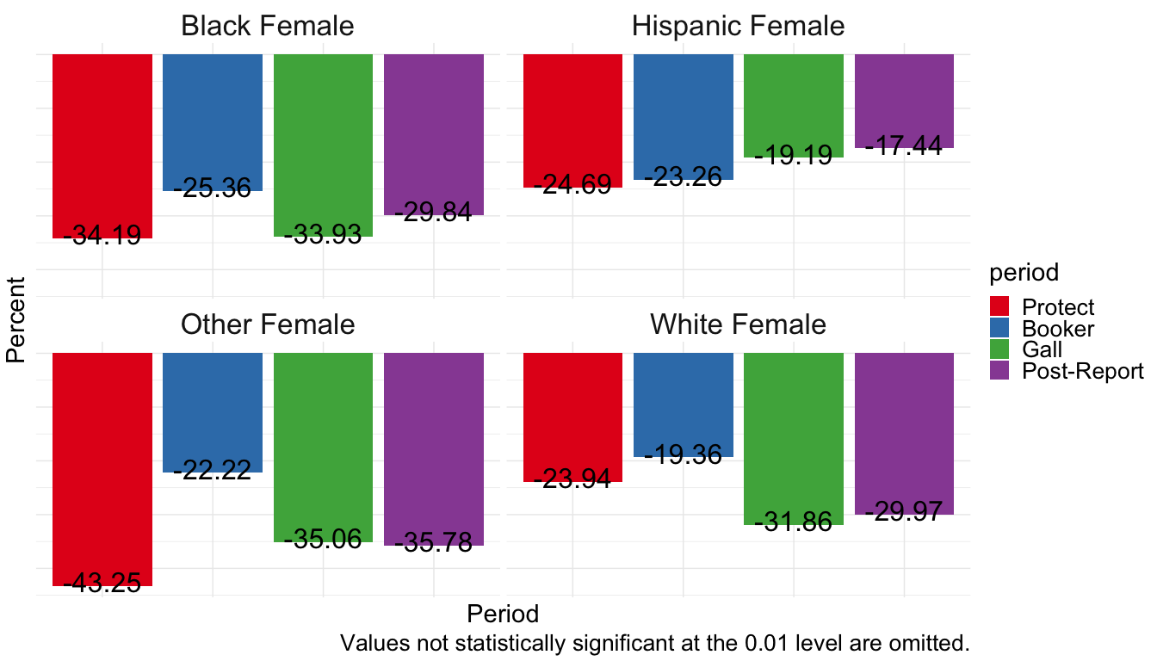
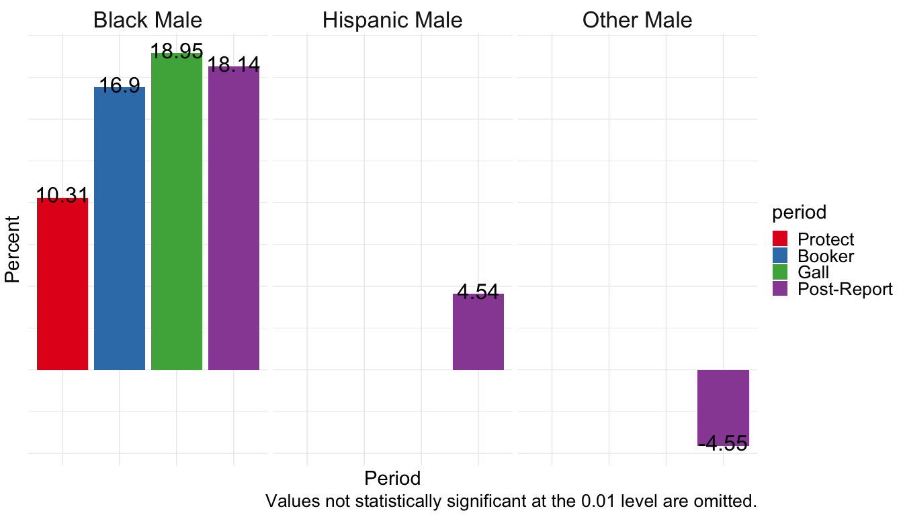

White Female Baseline
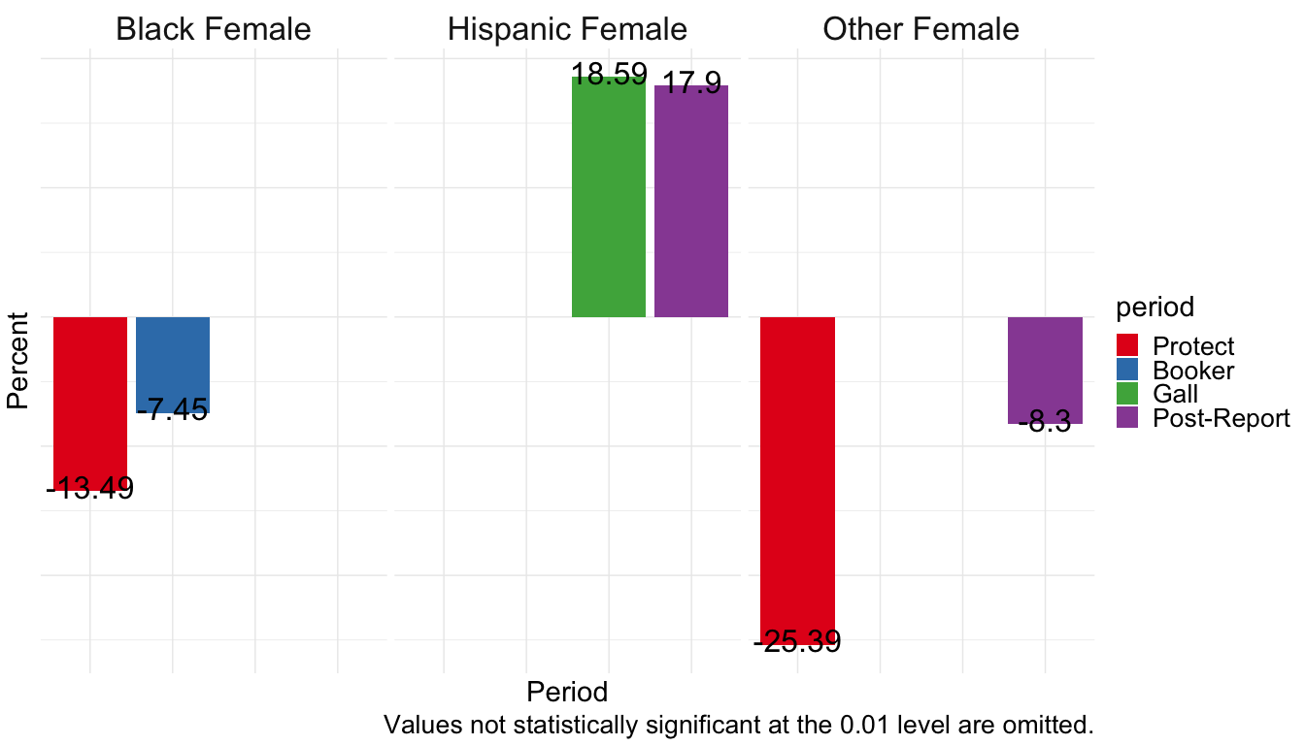
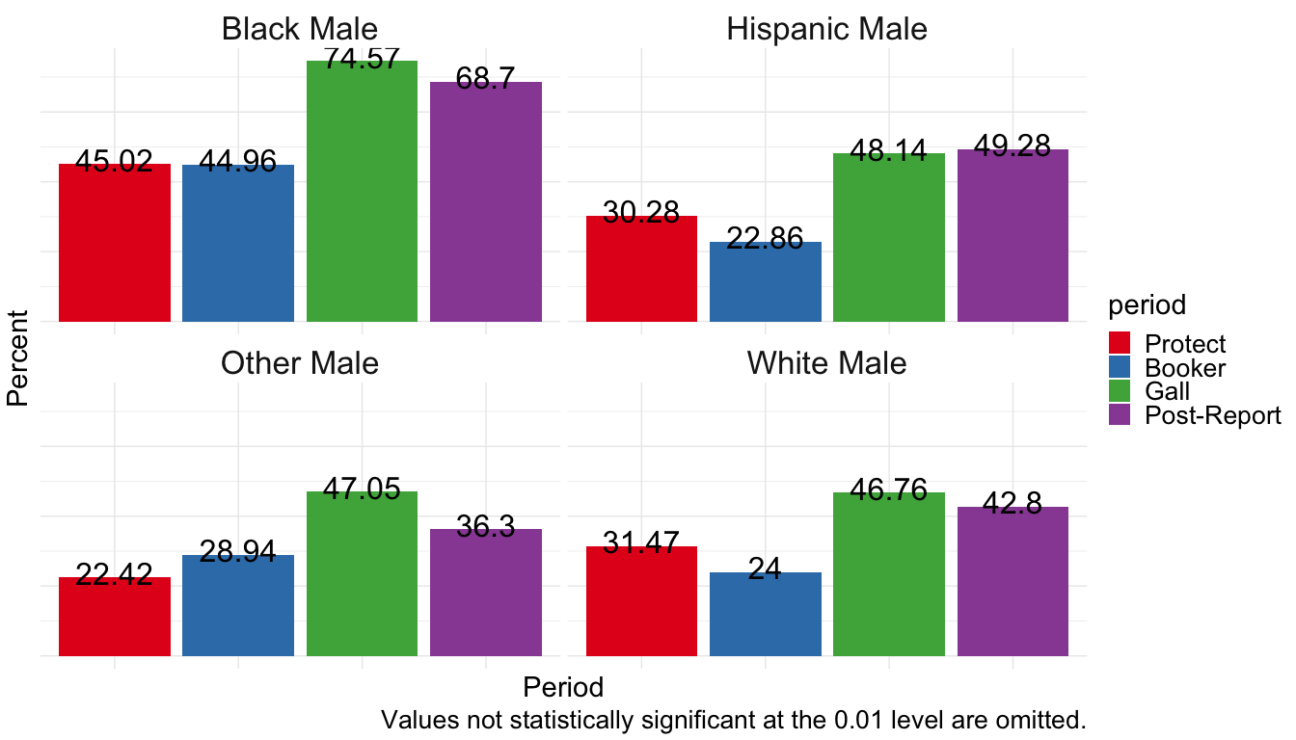

Hispanic Female Baseline
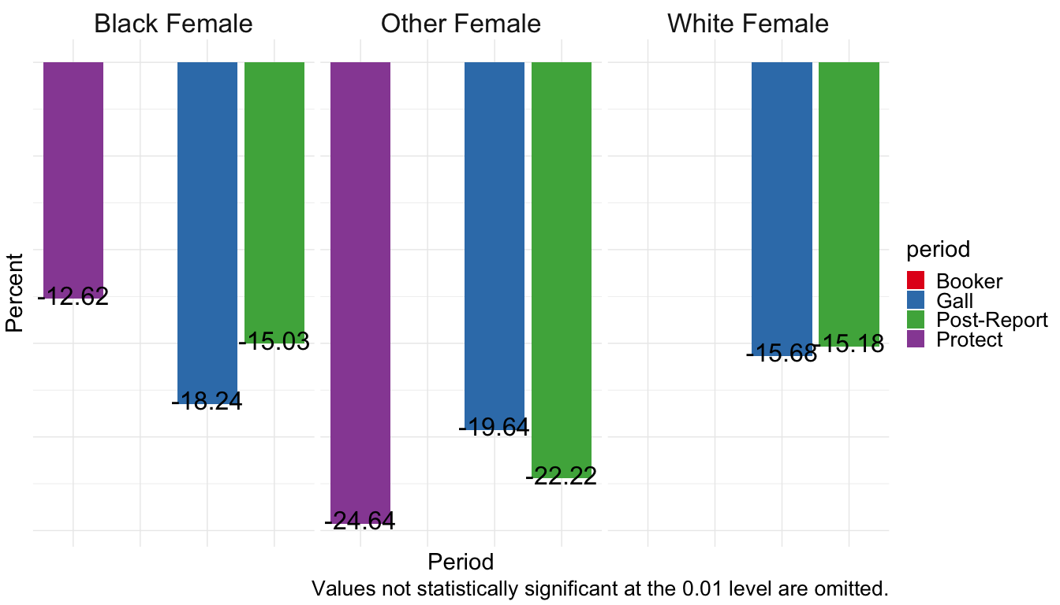
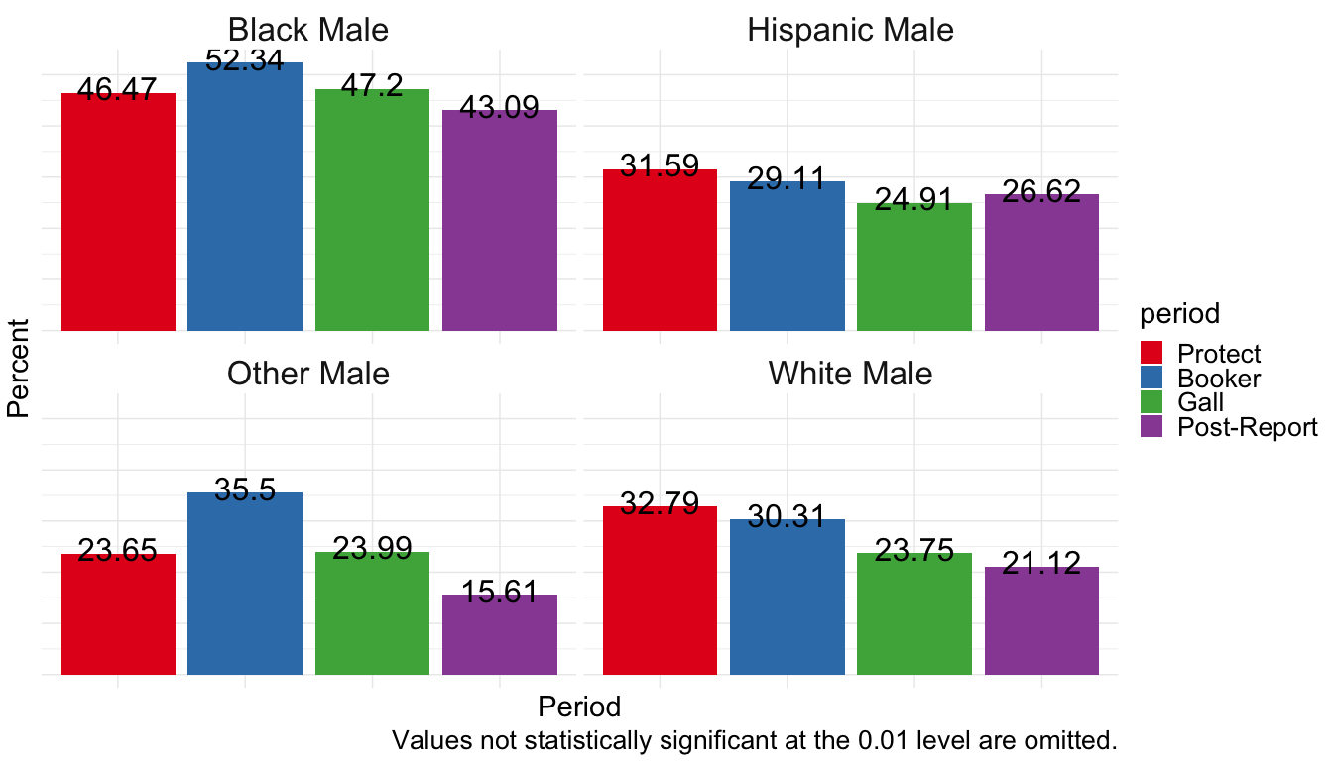

Black Female Baseline
